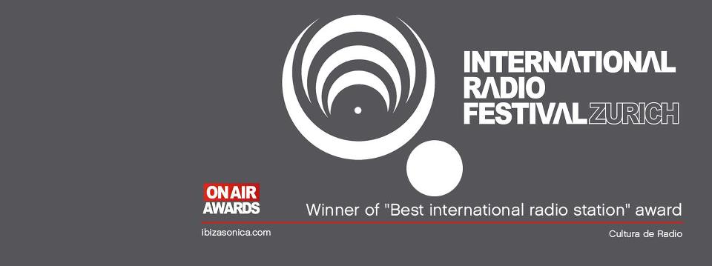
::‘IBIZA SONICA , WORLD’S BEST RADIO STATION’ SAYS INTERNATIONAL RADIO FESTIVAL ::
On September 15th Ibiza Sonica http://www.ibizasonica.com/ was awarded the Best International Radio On Air Award by the International Radio Festival http://www.internationalradiofestival.com/ in Zurich, the annual gathering of the radio industry. The Swiss festival, with the slogan “Listen to how the world sounds” , offers radio professionals from all over the world a platform to network and debate the present and future of radio.
The Best International Radio award marks the culmination of the 2011/2012 season and is a recognition by the festival of Sonica’s mission to “raise the standards of radio and create new styles and formats of broadcasting”. Ibiza Sonica has broadcast from the great clubs (Amnesia, Space, Pacha, Privilege, GOA…) from festivals (International Music Summit, Fresh Weekend, SONAR…) and from many special locations: sailing boats, beaches in México, jungles in Brasil, clubs in China, art exhibitions, street processions or Carl Cox’s kitchen.
It all began in 2006 when Igor Marijúan , Miguel Valverde and Andy Wilson created Ibiza Sónica with the idea of bringing a piece of Ibiza to the world through music and the Internet . From the local to the global, during these years the station has grown exponentially,currently reaching over 6 million listeners a month, and has earned the respect of artists and DJs the world over. And now, recognition from the radio industry is following that of the listeners and the artists with this award which can be added to the Premio Especial a la Calidad Radiofonica (Deejay mags, 2009), the Media Award (International Dj Awards, 2010) and Best Music Cloudcaster (Mixcloud awards 2010).
The team of Ibiza Sonica want to show their gratitude “for receiving this recognition of our work, and most of all for receiving it for doing what we love : sharing music and good times over the radio with all our listeners”.
____________________________________________________________________________
The 8th ,9th and 10th of October Isleña Music Sessions presents the best sessions of 2012 in the Ibiza Sonica Radio Festival. 72 hours of non-stop music with sets from Carl Cox, Sven Vath, Steve Lawler, Josh Wink, Seth Troxler, Maceo Plex, Solomun, Nic Fanciulli and many more.

